Exercise 6. Polymerase Chain Reaction

Objectives
The Polymerase chain reaction is an essential technique in molecular biology and genetic engineering. In this exercise, you will learn the major features of a PCR reaction. You will isolate your DNA from cheek tissue. Starting from this small amount of template, you will amplify the DNA to microgram quantities. The template you will amplify is a gene encoding the enzyme alcohol dehydrogenase, a protein that converts alcohol to acetaldehyde. You will then be given the option of sequencing the gene that has been amplified to identify any possible mutations.

PreLab Questions 6

- Consider the following primers for a PCR reaction : Primer 1 has 60% CG content, Primer 2 has 30% CG content. If calculated melting temperatures for these two primers are the same, which primer is longer? Briefly describe why?
- A subsequent step after PCR is the incorporation of a gene into a plasmid. Consider a plasmid with two restriction sites, EcoRI and SspI. What steps would you have to take before and after PCR to insert this gene.
- The DNA polymerase used in PCR is isolated from a thermophilic organism. What about the PCR reaction makes this necessary?
- How long is the polymerization step in this lab? What factor influences this?

Background
A short time after its invention in 1985, polymerase chain reaction (PCR) grew to become an essential and established technique in molecular biology, genetic engineering, and biochemical engineering. This technique allows us to amplify a small amount of DNA, or template, from very few copies to many micrograms of material, a very powerful capability with applications throughout all of biology.
A PCR reaction contains a small amount of template DNA, DNA oligonucleotide primers, a DNA polymerase enzyme, and deoxynucleotide monomers. The amplification proceeds by cycling through several steps of the reaction, shown on the next page. First, the reaction is heated to ~95°C to separate the two template strands, or denature the DNA. The reaction is then cooled to ~45-65°C to allow annealing or hybridization between the template and small, single stranded oligonucleotides. These primers are designed with homology flanking the region to be amplified, and the annealing temperature is a key parameter that must be optimized for each PCR reaction. The temperature is then raised to ~72°C to allow the polymerase to use the deoxynucleotide monomers to extend the primers and generate double stranded products. Assuming 100% efficiency, the amount of product is doubled each cycle, and a reaction is typically run through ~30 cycles. After several cycles, the short, amplified product dominates over the long template.
In addition to amplification of a small amount of template, PCR can be used in various strategies to isolate a high concentration of a single gene, add novel restriction enzymes to the ends of a product, introduce mutations into a product, or fuse two sequences together. This lab will use PCR for the first application, in order to isolate a human gene.

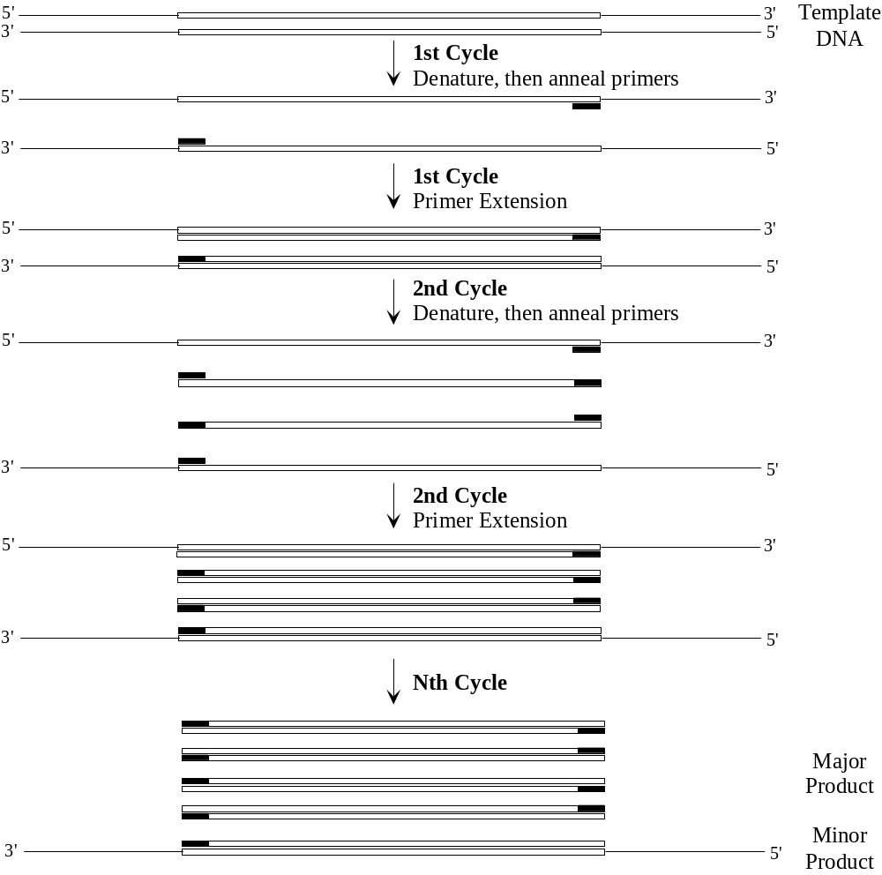

Procedures
NOTE: Sterile technique is required for all protocols; this is especially important when you are growing cultures in antibiotic-free medium. Use a flame, cover things, and if a specimen is thought to be contaminated, trust your judgment and start over. All “sterile” items provided to you were packaged sterile or were autoclaved at 121o C. Remember to read procedures carefully and do any necessary calculations before coming to lab, so time won’t be wasted while in lab. Also, label everything clearly, as large numbers of tubes and flasks can easily be confused.

Isolation of total DNA from cheek cells

1. Pipet 180 μl Buffer ATL into a microcentrifuge tube. Using a sterile cell scraper (or inoculating loop), scrape some cells from inside of your cheek and dip into the Buffer ATL (promotes tissue lysis)

2. Add 20 μl proteinase K. Mix thoroughly by vortexing, and incubate at 56°C until the tissue is completely lysed. Vortex occasionally during incubation to disperse the sample (catalyses protein degradation)

Lysis time varies depending on the type of tissue processed. Lysis is usually complete in 1h.

3. Vortex for 15 s. Add 200 μl Buffer AL to the sample, and mix thoroughly by vortexing. Then add 200 μl ethanol (96–100%), and mix again thoroughly by vortexing. (Buffer AL promotes binding of DNA to spin column).

It is essential that the sample, Buffer AL, and ethanol are mixed immediately and thoroughly by vortexing or pipetting to yield a homogeneous solution. Buffer AL and ethanol can be premixed and added together in one step to save time when processing multiple samples. A white precipitate may form on addition of Buffer AL and ethanol. This precipitate does not interfere with the procedure

4. Pipet the mixture from step 3 (including any precipitate) into the spin column placed in a 2 ml collection tube . Centrifuge at _6000 x g for 1 min. Discard flow-through and collection tube.

5. Place the spin column in a new 2 ml collection tube, add 500 μl Buffer AW1, and centrifuge for 1 min at _6000 x g. Discard flow-through and collection tube. (Wash step 1)

6. Place the spin column in a new 2 ml collection tube, add 500 μl Buffer AW2, and centrifuge for 3 min at 20,000 x g to dry the membrane. Discard flow-through and collection tube. (Wash step 2)

It is important to dry the membrane of spin column, since residual ethanol may interfere with subsequent reactions. This centrifugation step ensures that no residual ethanol will be carried over during the following elution.Following the centrifugation step, remove the DNeasy Mini spin column carefully so that the column does not come into contact with the flow-through.

7. Place the spin column in a clean 1.5 ml microcentrifuge tube and pipet 200 μl Buffer AE directly onto the membrane. Incubate at room temperature for 1 min, and then centrifuge for 1 min at _6000 x g to elute.

Preparation of Reaction and Cycling

- You will be provided with 10x polymerase buffer, a 10 mM dNTP solution, and a 50 μM solution of each primer. After you have finished mixing the reaction, ask the GSI for 1 μl of Vent DNA polymerase. The reaction should be mixed in 200uL microfuge tube.

Mix the following reaction (50uL total volume):

1 μl 100 mM dNTPs
0.5 μl Forward primer
0.5 μl Reverse primer
2 μl DMSO
15 μl Template DNA
5 μl 10x polymerase buffer
1 μl Vent DNA polymerase (ADD LAST)
25 μl Water

(Add the 1 μl of Vent DNA polymerase just before you are ready to place the reaction in the thermocycler.)

- Place the reaction in the thermocycler. The following program has already been set:

5 minutes initial denaturation at 94°C

8 cycles: 30 seconds denaturation at 94°C
30 seconds annealing at 53°C
1.5 minute polymerization at 72°C

10 cycles: 30 seconds denaturation at 94°C
30 seconds annealing at 57.5°C
1.5 minute polymerization at 72°C

18 cycles: 30 seconds denaturation at 94°C
30 seconds annealing at 62°C
1.5 minute polymerization at 72°C

10 minutes final extension at 72°C

Forever proper storage at 4ºC until next lab

This program will take approximately two hours to run. Your samples will remain in the thermocycler until the next lab period.

Analyzing your PCR products (Day Two)

- Cast a 1.4% agarose gel. Remove your samples from the thermocycler and aliquot 25uL into a separate microcentrifuge tube. To this tube, add 6x running buffer (as done previously) and run it on the gel next to a DNA standard ladder to make sure the reaction worked. You should see a band at ~1500 bp (plus a smear of low molecular weight unincorporated primers and dNTPs.

- If you wish to have your PCR samples sequenced, notify the GSI, label the remaining PCR sample with your lab group / initials, and store the sample in the freezer.

Guidelines for Analysis & Conclusions Section
(Remember, these are points you should consider and include in your analysis. This section, however, need not be limited to these specific guidelines.)

1. The sequence for ADH1B is shown below. Suggest the sequences of potential primers that were used in this experiment, and calculate the approximate melting temperature of your primers. Also, what hybridization temperature/s should you use in your PCR reaction for your primers. How might a step up in temperatures (as performed in the lab) help with annealing?

0 ATGAGCACAG CAGGAAAAGT AATCAAATGC AAAGCAGCTG TGCTATGGGA
50 GGTAAAGAAA CCCTTTTCCA TTGAGGATGT GGAGGTTGCA CCTCCTAAGG
100 CTTATGAAGT TCGCATTAAG ATGGTGGCTG TAGGAATCTG TCACACAGAT
150 GACCACGTGG TTAGTGGCAA CCTGGTGACC CCCCTTCCTG TGATTTTAGG
200 CCATGAGGCA GCCGGCATCG TGGAGAGTGT TGGAGAAGGG GTGACTACAG
250 TCAAACCAGG TGATAAAGTC ATCCCGCTCT TTACTCCTCA GTGTGGAAAA
300 TGCAGAGTTT GTAAAAACCC GGAGAGCAAC TACTGCTTGA AAAATGATCT
350 AGGCAATCCT CGGGGGACCC TGCAGGATGG CACCAGGAGG TTCACCTGCA
400 GGGGGAAGCC CATTCACCAC TTCCTTGGCA CCAGCACCTT CTCCCAGTAC
450 ACGGTGGTGG ATGAGAATGC AGTGGCCAAA ATTGATGCAG CCTCGCCCCT
500 GGAGAAAGTC TGCCTCATTG GCTGTGGATT CTCGACTGGT TATGGGTCTG
550 CAGTTAACGT TGCCAAGGTC ACCCCAGGCT CTACCTGTGC TGTGTTTGGC
600 CTGGGAGGGG TCGGCCTATC TGCTGTTATG GGCTGTAAAG CAGCTGGAGC
650 AGCCAGAATC ATTGCGGTGG ACATCAACAA GGACAAATTT GCAAAGGCCA
700 AAGAGTTGGG TGCCACTGAA TGCATCAACC CTCAAGACTA CAAGAAACCC
750 ATCCAGGAAG TGCTAAAGGA AATGACTGAT GGAGGTGTGG ATTTTTCGTT
800 TGAAGTCATC GGTCGGCTTG ACACCATGAT GGCTTCCCTG TTATGTTGTC
850 ATGAGGCATG TGGCACAAGC GTCATCGTAG GGGTACCTCC TGCTTCCCAG
900 AACCTCTCAA TAAACCCTAT GCTGCTACTG ACTGGACGCA CCTGGAAGGG
950 GGCTGTTTAT GGTGGCTTTA AGAGTAAAGA AGGTATCCCA AAACTTGTGG
1000 CTGATTTTAT GGCTAAGAAG TTTTCACTGG ATGCGTTAAT AACCCATGTT
1050 TTACCTTTTG AAAAAATAAA TGAAGGATTT GACCTGCTTC ACTCTGGGAA
1100 AAGTATCCGT ACCGTCCTGA CGTTTTGAGG

- Use the anonymous sequences supplied by the GSI to perform a multiple sequence alignment. Include the correct sequence listed above in question 1.

Go to: http://www.ebi.ac.uk/clustalw/
Enter the sequences into the box supplied for sequences.
Remove all numbers and spaces from the sequence and enter as follows:

>ADH1B_1 (or give it a meaningful name)
ATGAGCACAGCAGGAAAAGTAATCAAATGC….

>ADH1B_2
ATGA…

Etc.

Click the “run” button and scroll down to the results of the alignment. Do any of the sequences have mutations? How homologous are these sequences to each other (alignment score)? What does this tell you about human DNA?

- There are a lot of different DNA molecules in a PCR reaction. Discuss which ones you do and do not observe on your gel, and why.

- Discuss how PCR could be used in forensic analysis of crime scenes.

EQUIPMENT AND REAGENTS

A 1 mg/ml solution of the GFP template plasmid, pGFPuv
10x polymerase buffer
10 mM dNTP solution
50 μM solution of each primer
Sterile nanopure water
0.2 ml thin walled PCR tubes (supplied from MJ Research)
1.5 ml microcentrifuge tubes, non-sterile

Sterile micropipet tips
Taq DNA Polymerase (Life Technologies)
Electrophoresis unit. Includes power supply, box, plate, and sample comb.
Gel camera
Digital camera for gel pictures
UV light box
Commercial Molecular Weight Marker, 1 kb DNA ladder from Fermentas
Ethidium Bromide (EtBr): Stock Solution at 10 mg/ml
Agarose (Electrophoresis-grade)
10X loading buffer (see Ex 3 for composition)
50X TAE Gel Electrophoresis Buffer (see Ex 3 for composition)

REFERENCES
Newton, C.R., Graham, A. (1997) PCR – Introduction to Biotechniques, BIOS Scientific Publishers, Oxford.
Sambrook, Fritsch, and Maniatis. (1989) Molecular Cloning - A Laboratory Manual, 2nd ed., pp. 1.85 – 1.86, Cold Spring Harbor Laboratory Press.
Voet, D., Voet, J.G. (1990) Biochemistry, pp. 824-829, John Wiley and Sons, New York.

